C:\Documents and Settings\koeby.johnson\Local Settings\Temporary Internet Files\Content.IE5\8FN35SSX\MC900101138[1].WMF101 Facts About Ancient Rome

* Typed or VERY NEATLY hand-written
* Illustrate some of the facts with clip art or original drawings
* 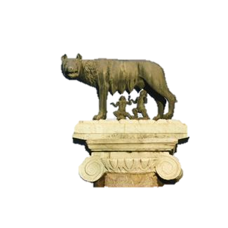To reach 101 facts, here are some possible sources of information:
* Google Earth 🡪 Layers 🡪 Gallery 🡪 Ancient Rome 3D
* <http://johnsonsocialstudies.weebly.com/>

\* Projects Tab 🡪Encyclopedia of Ancient Rome

\* Resources Tab

* You must include a Works Cited page, so I know where your information was found! The 75 facts from class are all from our textbook, and that is already formatted as the “Book With a Single Author” example on your Works Cited Format page.
* Minimum number of sources on Works Cited page = THREE!!!

DUE: Friday, February 24th!

C:\Documents and Settings\koeby.johnson\Local Settings\Temporary Internet Files\Content.IE5\8FN35SSX\MC900101138[1].WMF101 Facts About Ancient Rome

* Typed or VERY NEATLY hand-written
* Illustrate some of the facts with clip art or original drawings
* To reach 101 facts, here are some possible sources of information:
* Google Earth 🡪 Layers 🡪 Gallery 🡪 Ancient Rome 3D
* <http://johnsonsocialstudies.weebly.com/>

\* Projects Tab 🡪Encyclopedia of Ancient Rome

\* Resources Tab

* You must include a Works Cited page, so I know where your information was found! The 75 facts from class are all from our textbook, and that is already formatted as the “Book With a Single Author” example on your Works Cited Format page.
* Minimum number of sources on Works Cited page = THREE!!!

DUE: Friday, February 24th!