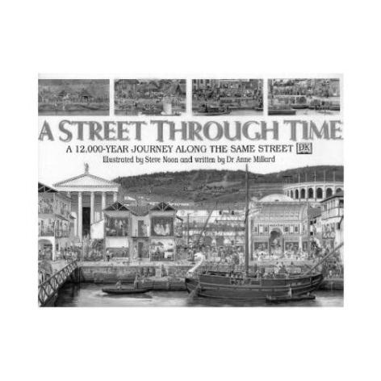**A** Street Through Time:

Name_______________________

Period________ Date_________

12,000 Years on the Same Street!

***Instructions - By comparing the pictures in your packet answer the following questions. You will find this task to be much easier if you arrange the pictures in chronological order.***

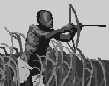

1 – Looking at the Stone Age Hunters and the First Farmers illustrations, what is the difference in fishing techniques?

2 – In the Stone Age Hunters illustration, what are their houses made of? Why do you think they chose this material?



3 – What are three new industries featured on the First Farmers picture?

4- In the picture The Iron Age what has changed with the practice of trading? Why do you think this happened?

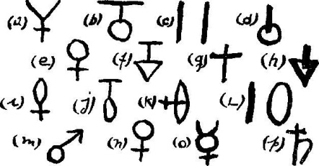

5- Looking at the Iron Age and the Stone Age how are the featured religious figures different? Why do you think they are worshiping different things?

C:\DOCUME~1\hdmslib\LOCALS~1\Temp\Temporary Internet Files\Content.IE5\S9EGNVWC\MC900149420[1].WMF

6- In the illustration Roman Times no one seems to be farming. Where do you think the food is being grown?

7 – What allowed the small village seen in the picture the Iron Age, to become the town you see in Roman Times?

8 – What is one new type of transportation you can see in the picture Roman Times?

9 – What happened to the town between the pictures Roman Times and The Invaders?

10 – What Gods or Goddesses do you see in the picture Roman Times?

11 – In the picture The Invaders there is no trade going on. Why do you think there is no trade?

12 – In the picture The Invaders what is different about where the animals are living? What are some advantages and disadvantages of keeping animals in this way?

C:\DOCUME~1\hdmslib\LOCALS~1\Temp\Temporary Internet Files\Content.IE5\S9EGNVWC\MC900355911[1].WMF

13 – In the picture Viking Raiders what religion do the villagers belong to?

14 – Why did the villagers give up much of their freedom in the picture Medieval Village?

C:\DOCUME~1\hdmslib\LOCALS~1\Temp\Temporary Internet Files\Content.IE5\DIWHYQ47\MC900116158[1].WMF

15 – What new building material do you see in the picture Medieval Village?

16 - What is one new piece of technology you see in the picture Medieval Village? How could it make life better for the people living in this time?

17 – The people in the picture Medieval Town have more freedoms than those in the Medieval Village. How did they get them?

18 – In the picture Medieval Town why do you think the water would be dirty?

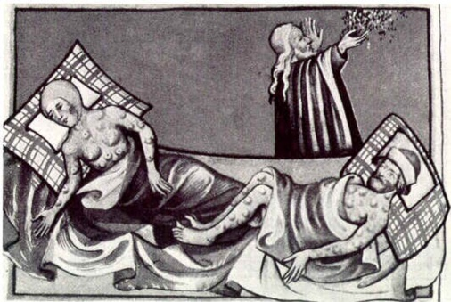

19 – Why are there fewer people in the picture The Plague Strikes than in the previous picture?

20 – Why is there no trade going on in the picture The Plague Strikes?

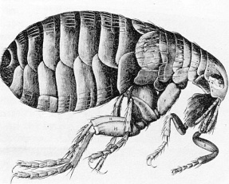21 – An important new invention that makes sharing ideas easier can be seen in The Plague Strikes. What is it?

22 – What new invention made war so much more dangerous in the picture Under Attack?

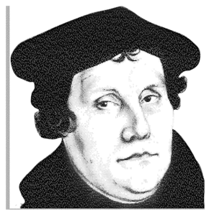

23 – Why do you think people are fighting over religion in the illustration Under Attack?

24 – Looking at An Age of Elegance, why do you think they did not rebuild the castle?

25 – What are some of the new leisure activities you can see in An Age of Elegance?

26 – In An Age of Elegance what do you think allowed the wealthy to have so much free time?

27 – What new power sources do you see in Grim Times?

C:\DOCUME~1\hdmslib\LOCALS~1\Temp\Temporary Internet Files\Content.IE5\11ZUE5BL\MC900116014[1].WMF

28 – What new modes of transportation do you see in Grim Times?

29 – Would you want to live in the city pictured in Grim Times? Why or why not?

30 – Look at the bottom left side of the picture Grim Time. How is waste being disposed of? How do you think this would affect quality of life?

31 – List three new types of transportation seen in From Town to City.

32 - What new type of settlement do you see in From Town to City?

C:\DOCUME~1\hdmslib\LOCALS~1\Temp\Temporary Internet Files\Content.IE5\11ZUE5BL\MC900019536[1].WMF33 – What new piece of technology is making a new type of art possible in From Town to City?

34 – Look at From Town to City and Medieval Town. How are the businesses different?

35 – What new types of transportation do you see in The Street Today?

36 – What is the difference between the bathroom in The Street Today and the bathrooms we have seen in previous pictures?

37 – Do you notice any technology in The Street Today that is also featured in The Stone Age Hunters?

38 – What are the most interesting things you learned from reading A Street Through Time?



39 – Which time period (besides today) would you choose to live in and why?

40 – Which period would be your last choice and why?