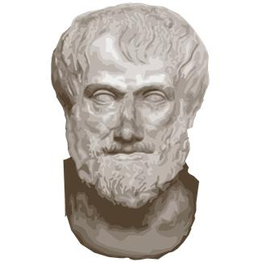
Ancient Greek Quotes

Name_______________________________

Date________________ Period __________
Use WikiQuotes (http://en.wikiquote.org) to find quotes by famous ancient Greeks.
Look for quotes that contain GREAT WISDOM, are good advice, make you think, or make you laugh!

Name  Occupation  Born – Died | Quote | What the quote means in your own words
(Example)  Plato  Philosopher  427BC – 347 BC | “The beginning is the most important part of the work.” | To end up doing a really good job with your work, you have to get it started!
Pythagoras

Heraclitus

Socrates

Plato
Philosopher
427BC – 347 BC
Aristotle

Your Choice
Greek Proverb

(A proverb is a simple saying popularly known and repeated, which expresses a truth, based on common sense or the practical experience of humanity. Example: “Haste makes waste.”)

Greek Proverb
Greek Proverb
Finished? Bring your best finds to Mr. Johnson to put on the class website!

