Jennifer Alvarez
December 4, 2013
Period 1

Ancient Rome in Google Earth and Wikipedia!

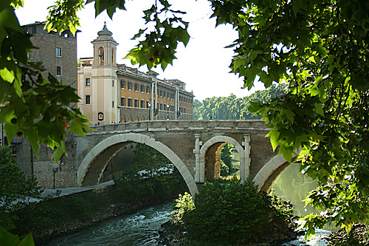

Pons Fabricius
Name of the site
“The Pons Fabricius (Italian: Ponte Fabricio, meaning "Fabricius' Bridge") or Ponte dei Quattro Capi, is the oldest Roman bridge in Rome, Italy, still existing in its original state. Built in 62 BC, it spans half of the Tiber River, from the Campus Martius on the east side to the Tiber Island in the middle. The bridge was built of stone in 62 BC, to replace an earlier wooden bridge destroyed by fire. Completely intact from Roman antiquity, it has been in continuous use ever since.”
Original
text from Wikipedia

The Pons Fabricius has been in use since it was built in 62 BC. It is a beautiful stone bridge connecting the shore of the Tiber River to the Tiber Island. It is simple and pretty, and is the oldest bridge in Rome. It allows people to travel to the Tiber Island!
My summary and analysis, which is not plagiarized!

- Start by looking throughout the city of Rome, Italy for interesting buildings
- When you see something that catches your eye, turn on the Wikipedia icons
- Read about the site and decide if it is from ancient Rome (753BC-AD476)
- Copy the title and at least one paragraph of text from the Wikipedia description, to use when you summarize
- Find a photo of the building, copy it, and paste it above your title, summary, and analysis
- Proofread for errors, fix them, and then print out a copy to turn in!

