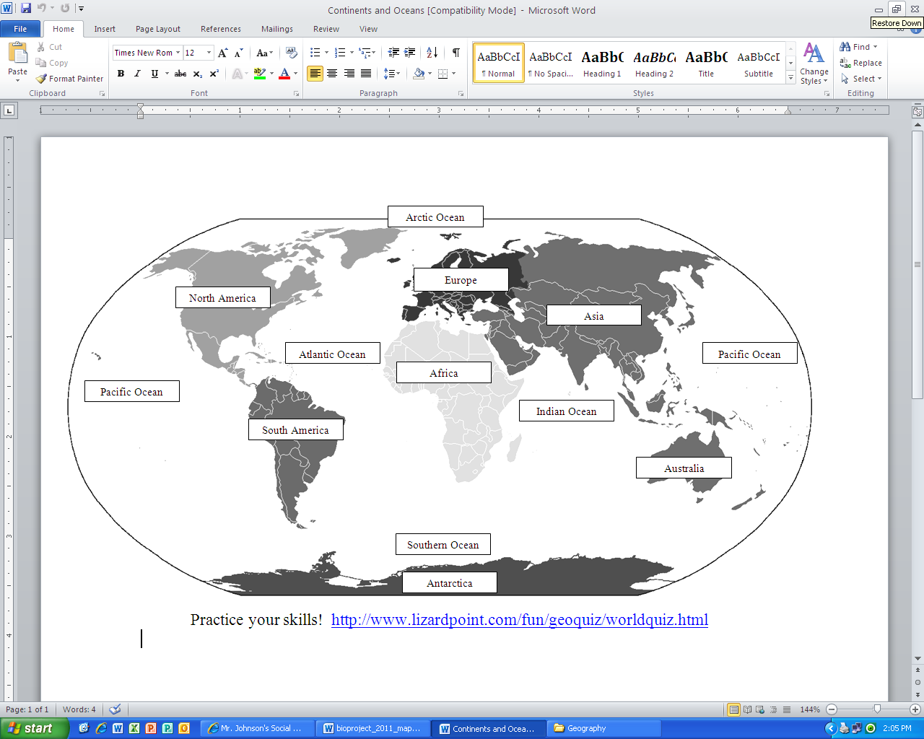

**7 Continents and 5 Oceans**

**7 Continents and 5 Oceans**