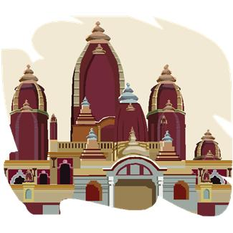
The Meeting of Greece and India
After conquering Anatolia (334-3 BCE), Phoenicia, Egypt and Libya (333-2 BCE) and finally Persia (331-330 BCE), Alexander the Great from Macedonia set his sights on the lands in northern India conquered by Darius I of Persia 200 years earlier. Alexander sent his main army through the Khyber Pass, and brought the rest himself on a more northerly route. He met with resistance and battles from some local rulers, while others feared his reputation and met him with gifts and supplies. His expedition reached its most easterly point in September 326 BCE at the Beas river in the Punjab when his army—now weary of long years spent on the march—came close to mutiny. Alexander then turned back heading southwards down the Indus to the sea, fighting and besieging Indian cities all the way. There he divided his men again, sending a fleet from the mouth of the Indus back to the Persian Gulf, dispatching one army corps over the Bolan Pass, and taking the rest along the inhospitable Makran coast into Iran and back to Babylon.
Alexander's invasion itself left no long lasting impression on India (though he may have influenced the young Chandragupta Maurya, founder of the Mauryan Empire), but his campaigns cemented his reputation as one of the great conquerors of the ancient world. Later Greek leaders however conquered much of northwest India; the most famous, Menander (ruled c. 155-130 BCE), struck down the Ganges as far as Patna and according to legend later became a Buddhist.
Megasthenes was a Greek ambassador sent, in about 300 BCE, to the court of Chandragupta Maurya, the founder of the Mauryan Empire. Megasthenes represented Seleucus Nicator (lived 358-281 BCE), ruler of the eastern part of the Hellenistic Greek empire after Alexander the Great's death. Megasthenes' account of his visit (which survives only in fragments) has provided scholars with an understanding of the nature of Mauryan rule under Chandragupta. Megasthenes described the Indian caste system, the absolute rule of the Mauryan king and the sophisticated bureaucracy that had been developed to enforce this rule. He also discussed the standing army that he says comprised 60,000 professional soldiers. Megasthenes' accounts of more mundane Indian produce such as sugarcane and cotton plants drew disbelief among his readers back in Greece who could not believe in plants that produced "sugar syrup" and "wool."

