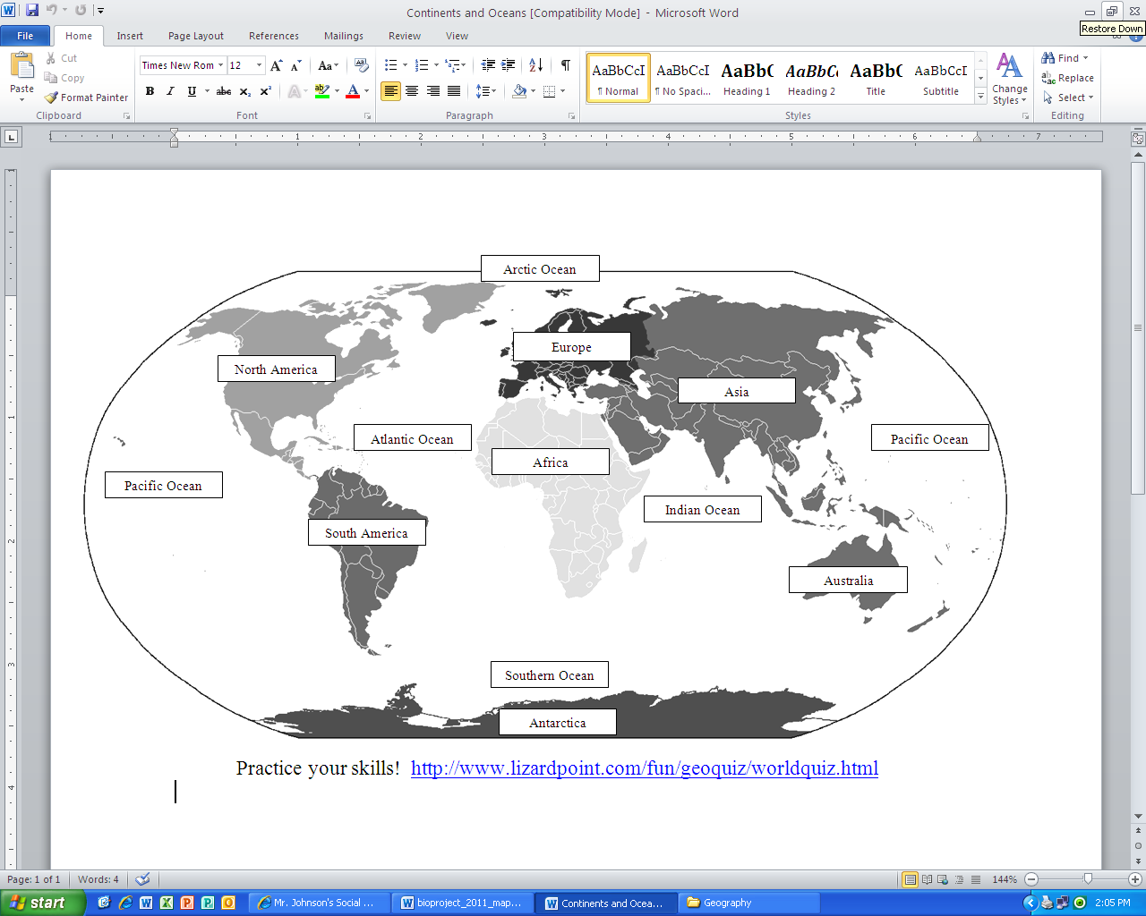

Prime Meridian =

0 degrees longitude

Equator =

0 degrees latitude

**7 Continents and 5 Oceans**

**7 Continents and 5 Oceans**