Social Studies Debate #2: “Should the U.S. tax system take more money from

Name___________________________

Date______________ Period ________
the wealthiest citizens to give to the poorest citizens?”
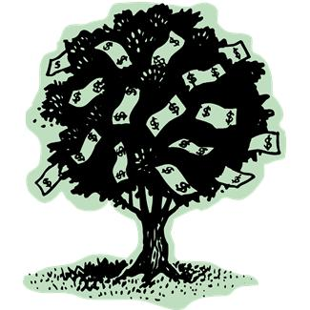
In the 6th century BCE, the ancient Greeks in Athens argued about canceling the debts of the poor, providing construction jobs paid with government funds, and taking money and land from the wealthy nobles to give to the landless poor. The “Occupy Wall Street” protestors and debates in congress are raising the same issues in the United States today.

Debate Preparation Notes
You need to use at least three sources of information:

- Interview a relative (who is old enough to have paid taxes) for their thoughts.
Name/Relation:
Notes:

- Find information (statistic, explanation, quote, etc.) from two sources on the web:
Source #1:
Information:

Source #2:
Information:

(Your conclusion must have at least three sentences and use evidence from multiple sources!)
My position is…

