Nations of East and Southeast Asia Map

1. Use the political map of Asia on pages R22-R23 of our textbook (or an online atlas or Google Earth) to find and NEATLY label all of the nations and bodies of water listed below. Please take care to write legibly! If the name of the country does not fit inside its territory, write it in the ocean, with a line connected to the country.
2. Cross each country and water body off the list after you label it, so you won’t skip any by mistake!
3. Carefully color the inside border of each country, so that no two neighboring countries are the same color.
4. Add a compass rose.
5. Carefully cut out the map and glue it into your comp book.
6. Neatly write your name, date and period outside the margins of the map!

**Bodies of Water**

**Pacific Ocean**

**Indian Ocean**

**Bay of Bengal**

**South China Sea**

**East China Sea**

**Yellow Sea**

**Java Sea**

**Philippine Sea**

**Sea of Japan**

**Sea of Okhotsk**

**Bering Sea**

**Countries**

**Brunei**

**Cambodia**

**China**

**East Timor**

**Indonesia**

**Japan**

**Laos**

**Malaysia**

**Mongolia**

**Myanmar**

**North Korea**

**Philippines**

**Russia**

**Singapore**

**South Korea**

**Taiwan**

**Thailand**

**Vietnam**

Instructions for the

Nations of East and Southeast Asia Map

are on the back of this page.

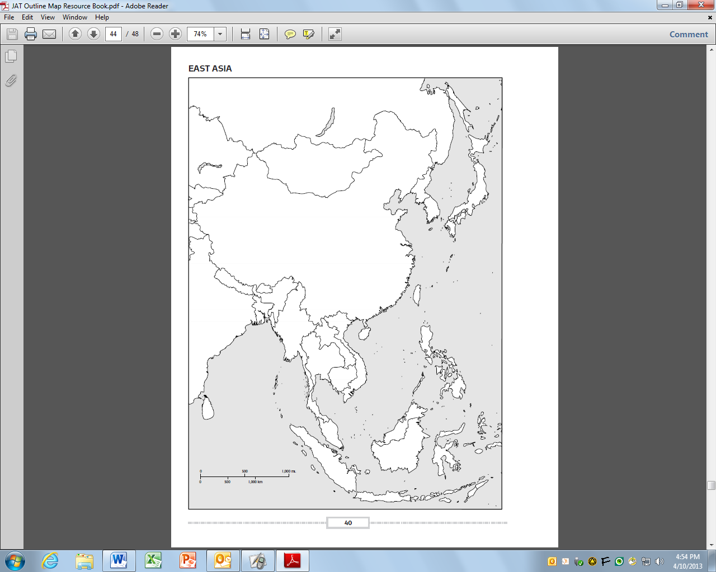

**Nations of East and Southeast Asia**