**C:\Documents and Settings\koeby.johnson\Local Settings\Temporary Internet Files\Content.IE5\ND0XPN9Q\MC900215022[1].WMFThe Encyclopedia of Ancient Rome**

**A Collaborative Website Project**

We are creating a class website page about ancient Rome!

<http://johnsonsocialstudies.weebly.com/>

In your group, you will work together on one section of the web page. Each person will start by individually reading the *Encyclopedia of Discovery* article on your topic, and then writing a bulleted list of 10-15 key facts in your comp books – using your own words to summarize. Once everyone is done with this step, the group should meet and use your bulleted lists to have a discussion about the key points in the article. One person should be the group’s note-taker. What are the main ideas of your topic? What are the 10-15 facts that your group decides should be included from this article?

Next, the group needs to choose who is going to do the following tasks:

* Additional Research (using books from the library and/or websites) to find more information on your group’s topic. You need a total of at least three sources of information, correctly cited! Give your notes and sources information to the rough draft writer.
* Write the rough draft of your group’s section with information from the

*Encyclopedia of Discovery* article as well as additional research. Follow the format of Mr. J’s section on the website.

* Edit and type up the final copy of your section, including the Works Cited, using Microsoft Word. Save this to a thumb drive, so it can be added to the image files and typed image captions.
* Search for photos, maps, illustrations, and images that will help people to understand your topic. Save these to a thumb drive as individual, named photo files. Type up a list of captions and save to the same thumb drive.
* Lunchtime or after-school website creator; this person will put all of the pieces together on our class website (with a bit of help from Mr. J). Format for the page will follow Mr. J’s example section.

***People can take multiple tasks and/or share jobs, as long as everyone contributes equally! Work cooperatively! Exchange names and email addresses or phone #s.***

**For the Works Cited format, please use the link on the website. Here are the citations for our *Journey Across Time* textbook and the *Encyclopedia of Discovery*:**

Spielvogel, Jackson J. *World History Journey Across Time The Early Ages*. Columbus: Glencoe McGraw Hill, 2008. Print.

“Title of Your Article.” *Encyclopedia of Discovery: Science and History*. 2002. Print.

***The general format for your section of our Encylopedia of Ancient Rome will look like this:***

Title of your section

**Ancient Roman Influences on the United States**

        The casual observer of history might wonder how there could be any connection between our American nation and the millenias-old culture of a peninsula in the Mediterranean Sea.  A closer look reveals that there are many ways that the developments of Ancient Rome contribute to the United States today, including our form of government, our public roads and infrastructure, and some of our architecture and art:  they all owe a debt of gratitude to the work of Romans 2,000 years ago!  
        A visit to Washington D.C. would quickly show how our government includes a Senate like that of Rome.  This group of law-makers works on a body of written law, not unlike Rome's original set of written laws, [The Twelve Tables](http://en.wikipedia.org/wiki/Twelve_Tables" \t "_blank).  Even our trial system, with a jury deciding whether or not an accused person is guilty or innocent, dates back to ancient Rome.  
        "All roads lead to Rome!"  This famous quote has its basis in the very real fact that Rome built almost 250,000 miles of very well-designed roads.  Their layered, sloped, paved roads were in use for over a thousand years.  They even developed public water and sewer pipe systems in their cities; we use the same basic ideas today.  
        To see the influence of Roman architecture on the United States, one can look at the grand dome of the [United States Capitol Building](http://weebly-file/5/7/7/0/5770558/us_capitol_picture.docx), or any other majestic, vaulted structure found throughout our nation.  Compare the Capitol Building dome to that of the [Pantheon](http://weebly-file/5/7/7/0/5770558/us_capitol_and_roman_pantheon.docx) in Rome, and you will find great similarities.  Even the attention to realistic detail found in statues throughout our country can be attributed to the work of ancient Roman artists, who took the advances of the Greeks before them, and added the "warts and all" details we take for granted today.  
        Whether we look at our government, infrastructure, art, or architecture, the same theme appears in all:  a lasting influence of the work of an empire based in the Mediterranean Sea, dating back two millenia!

Optional: you can make links to other websites or documents!

At least five paragraphs of informational text – use your own words and don’t plagiarize!

Works Cited  
  
Ancient Rome and the Roman Empire by Michael Kerrigan. Dorling Kindersley, London: 2001.

At least three sources of information

"Ancient Rome: from the Republic to the Empire."  Courtenay Middle School Library Website.  Web.

18 Feb 2011. <http://elibrary.sd71.bc.ca/subject_resources/socials/ancient_rome.htm>  
  
“Roads and Travel.” *Encyclopedia of Discovery: Science and History*. 2002. Print.

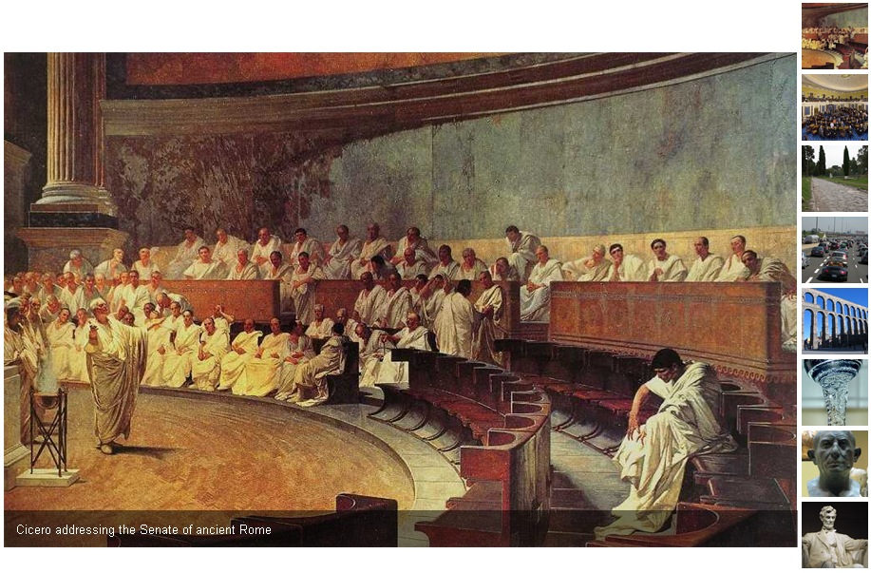"Roman Technology."  Wikipedia. Web.  18 Feb 2011. <http://en.wikipedia.org/wiki/Roman_technology>

Images will be added in the form of a slide show below the Works Cited. Each image will need a caption to explain what it shows.

*Article by Mr. Johnson*

Authors’ names

and date

*March 15, 2011*