Geography and Climate Zones in Africa Map

1. Use the map on page 445 of our textbook to learn about the geography of Africa.
2. Create a colored key for the four major climate zones of the map.
3. Carefully color each climate zone.

***Make sure the colors are light enough that you can legibly label over the colored areas!***

1. Neatly label all the mountains, deserts, oceans, seas, lakes, rivers, gulfs, capes, valleys, plateaus, basins, straits, and peninsulas which are shown on the map.
2. Add the equator, prime meridian, and a compass rose.
3. Carefully cut out the map and glue it into your comp book.
4. Neatly write your name, date and period outside the margins of the map!

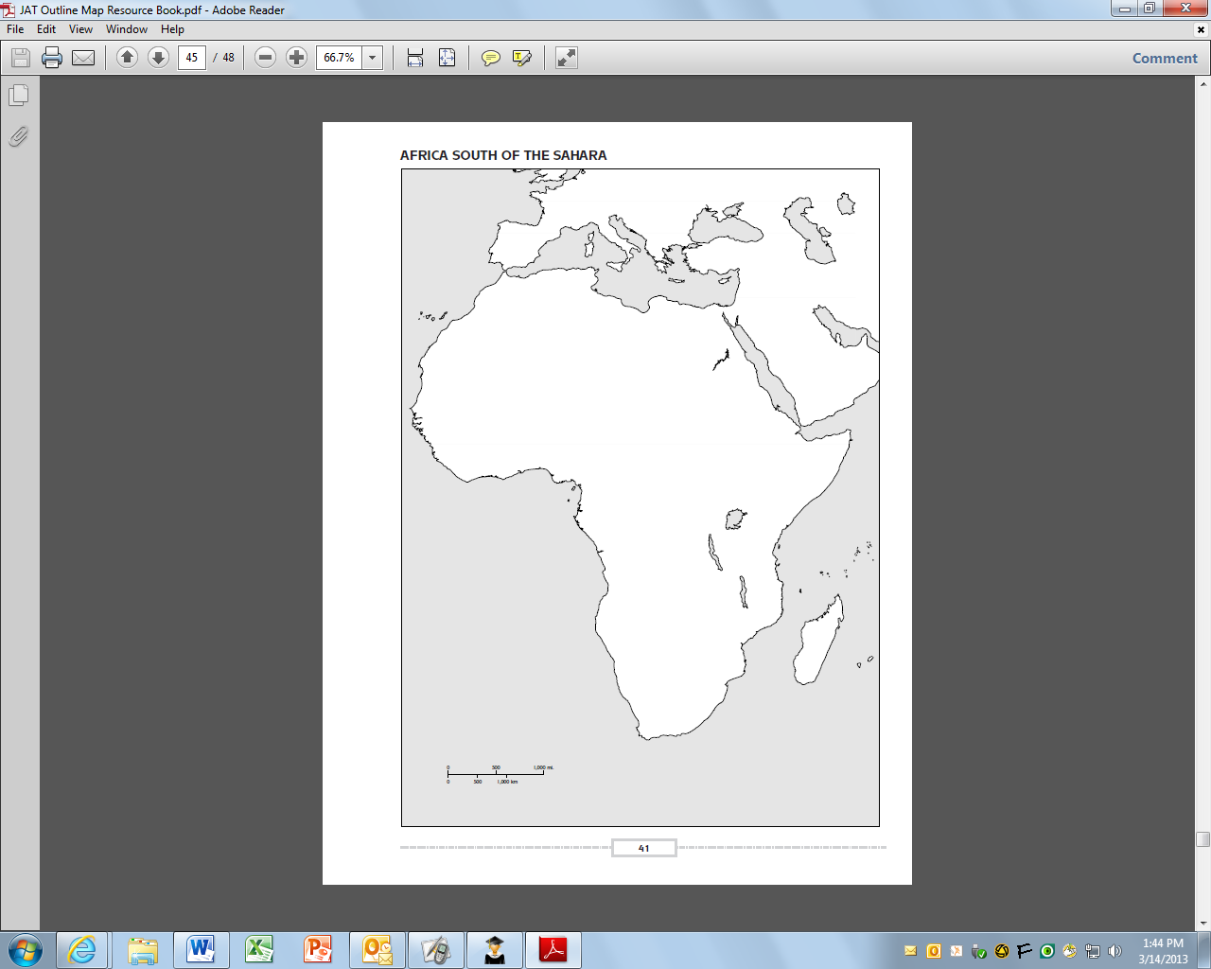

**Geography and Climate Zones in Africa**