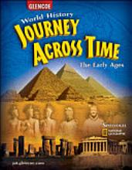
Our Social Studies class textbook,
Journey Across Time, is available online at this website: www.glencoe.com/ose
Access Code: F2FF0E72AC (the numeral after the FF is a zero)

If you are able to access and read this online textbook, and if your internet connection is dependable, you will not be required to carry a textbook back and forth between school and your home! Once you have made sure you meet the above requirements, please have a parent/guardian sign below.

I, _____________________________________, have dependable internet and computer access at home and would prefer to use the online textbook in social studies this year.

Parent Signature________________________________ Date ___________

Our Social Studies class textbook,
Journey Across Time, is available online at this website: www.glencoe.com/ose
Access Code: F2FF0E72AC (the numeral after the FF is a zero)

If you are able to access and read this online textbook, and if your internet connection is dependable, you will not be required to carry a textbook back and forth between school and your home! Once you have made sure you meet the above requirements, please have a parent/guardian sign below.

I, _____________________________________, have dependable internet and computer access at home and would prefer to use the online textbook in social studies this year.

Parent Signature________________________________ Date ___________

