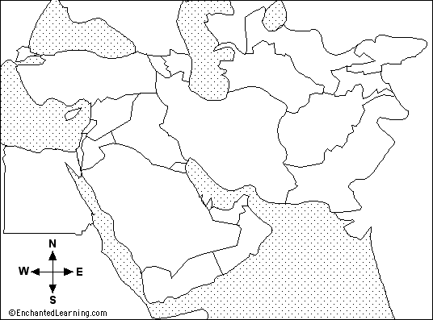

Bodies of Water

Arabian Sea - a large body of water south of the Middle East.
Aral Sea - a small sea located at the north of Uzbekistan.
Black Sea - a large body of water located north of Turkey.
Caspian Sea - a large body of water north of Iran, east of Azerbaijan, and west of Turkmenistan.
Gulf of Aden - the body of water between the Red Sea and the Arabian Sea; it is south of Yemen.
Gulf of Oman - the body of water between the Arabian Sea and the Persian Gulf; it is between Oman and Iran.
Mediterranean Sea - a large body of water between Europe and Africa.
Persian Gulf - a body of water off the Gulf of Oman; it is bordered by Iran, Kuwait, Saudi Arabia, Bahrain, Qatar, U.A.E., and Oman.
Red Sea - a long, thin body of water between Africa and the Arabian peninsula.
Countries are listed on the back
COUNTRIES
Label the following bodies of water and countries on the map. Use the reference section of your textbook on pages R18-19. Use the map on page 372 to label the towns of Mecca (Makkah) and Medina (Madinah).
Countries

Afghanistan - a landlocked country bordered on the west by Iran, on the south by Pakistan, and on the north by Turkmenistan, Uzbekistan, and Tajikistan.
Azerbaijan - a country on the western shores of the Caspian Sea; it is bordered by Armenia on the west and Iran on the south.
Armenia - a landlocked country bordered by Azerbaijan on the east, Iran on the south, and Turkey on the west.
Bahrain - a tiny country in the southern Persian Gulf bordered by Saudi Arabia.
Cyprus - a small, island country in the eastern Mediterranean Sea.
Egypt - a country in the northeast of Africa, bordered on the north by the Mediterranean Sea and on the east by the Red Sea.
Iran - a large country between the Persian Gulf and the Caspian Sea; it is bordered by Iraq and Turkey (on the west), Turkmenistan (on the northeast), Armenia and Azerbaijan (to the northwest), and Afghanistan and Pakistan (to the east).
Iraq - a country west of Iran, south of Turkey, east of Syria and Jordan, and north of Saudi Arabia.
Israel - a country on the eastern shores of the Mediterranean Sea bordered by Egypt on the southwest, Jordan on the east, and Lebanon on the north.
Jordan - a landlocked country south of Syria, west of Iraq, north of Saudi Arabia, and east of Israel.
Kyrgyzstan - a landlocked country north of Tajikistan and east of Uzbekistan.
Kuwait - a small country at the northwest of the Persian Gulf; it is bordered by Saudi Arabia (on the south) and Iraq (to the north).
Lebanon - a country on the eastern shores of the Mediterranean Sea bordered by Israel on the south and Syria on the northeast.
Oman - a country on the Arabian sea; it is bordered by Yemen on the southwest, Saudi Arabia on the west, and U.A.E. on the northwest.
Pakistan - a country north of the Arabian Sea, east of Iran, and south of Afghanistan.
Qatar - a tiny country on the Persian Gulf; it is bordered by Saudi Arabia and U.A.E.
Saudi Arabia - a country east of the Red Sea, bordered by Yemen, Oman, U.A.E., Kuwait, Iraq, Qatar, Bahrain, and Jordan.
Syria - a country in on the eastern shores of the Mediterranean Sea; it is bordered by Turkey (on the north), Iraq (on the east), Jordan (on the south), and Israel and Lebanon (on the southwest).
Tajikistan - a landlocked country south of Kyrgyzstan.
Turkey - a country located between the Black Sea and the Mediterranean Sea.
Turkmenistan - a country on the southeastern shores of the Caspian Sea; it is bordered by Iran on the south, Afghanistan on the southeast, by Uzbekistan on the northeast.
United Arab Emirates (U.A.E.) - a country bordering the Persian Gulf, Qatar, Saudi Arabia, and Oman.
Uzbekistan - a country south of the Aral Sea; it is bordered on the south by Turkmenistan, bordered on the southeast by Tajikistan, and bordered on the east by Kyrgyzstan.
Yemen - a country south of Saudi Arabia, bordered by the Red Sea and the Gulf of Aden.

