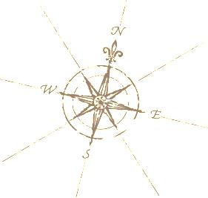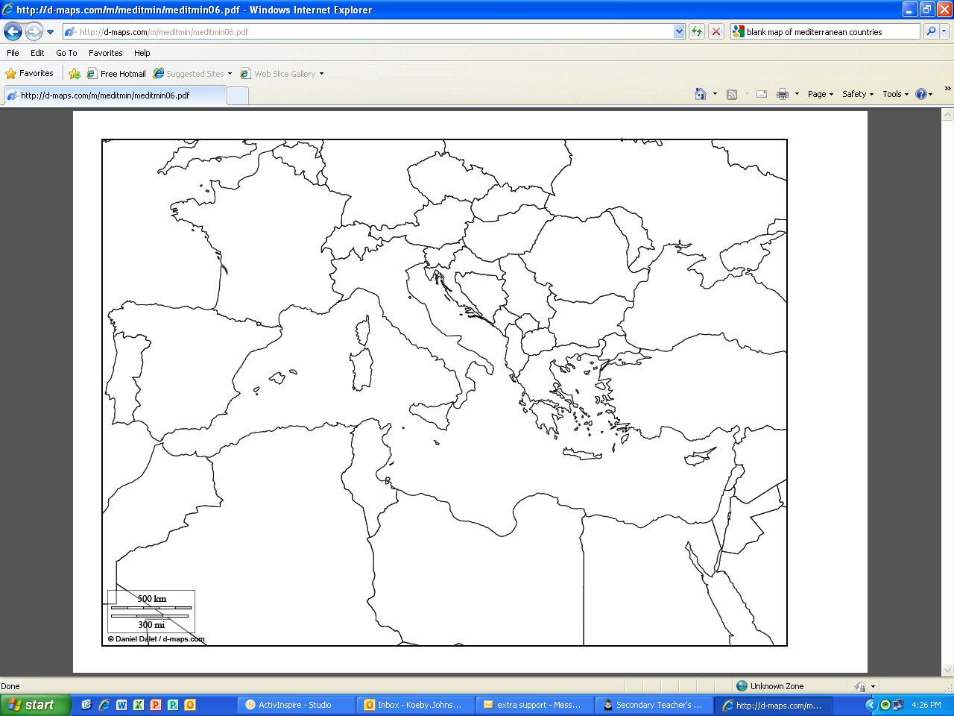

Here is a helpful site to help you study Mediterranean geography:

http://www.purposegames.com/game/mediterranean-countries-quiz

This map shows the nations which border the Mediterranean Sea. Carefully label each country on this map: **Spain, France, Monaco, Italy, Malta, Slovenia, Croatia, Bosnia & Herzegovina, Montenegro, Albania, Greece, Cyprus, Turkey, Syria, Lebanon, Israel, Egypt, Libya, Tunisia, Algeria, and Morocco**. Carefully color each labeled country, so that neighbors are different colors. Label the following seas and ocean, and color them blue: **Mediterranean Sea, Black Sea, Red Sea, Adriatic Sea, Aegean Sea, and Atlantic Ocean.** Now you know the modern names of some of the places we will look at in our study of ancient Greece, Persia, and Rome! *Hints: cross each place off after it is labeled on the map! Write neatly with a sharp pencil!*