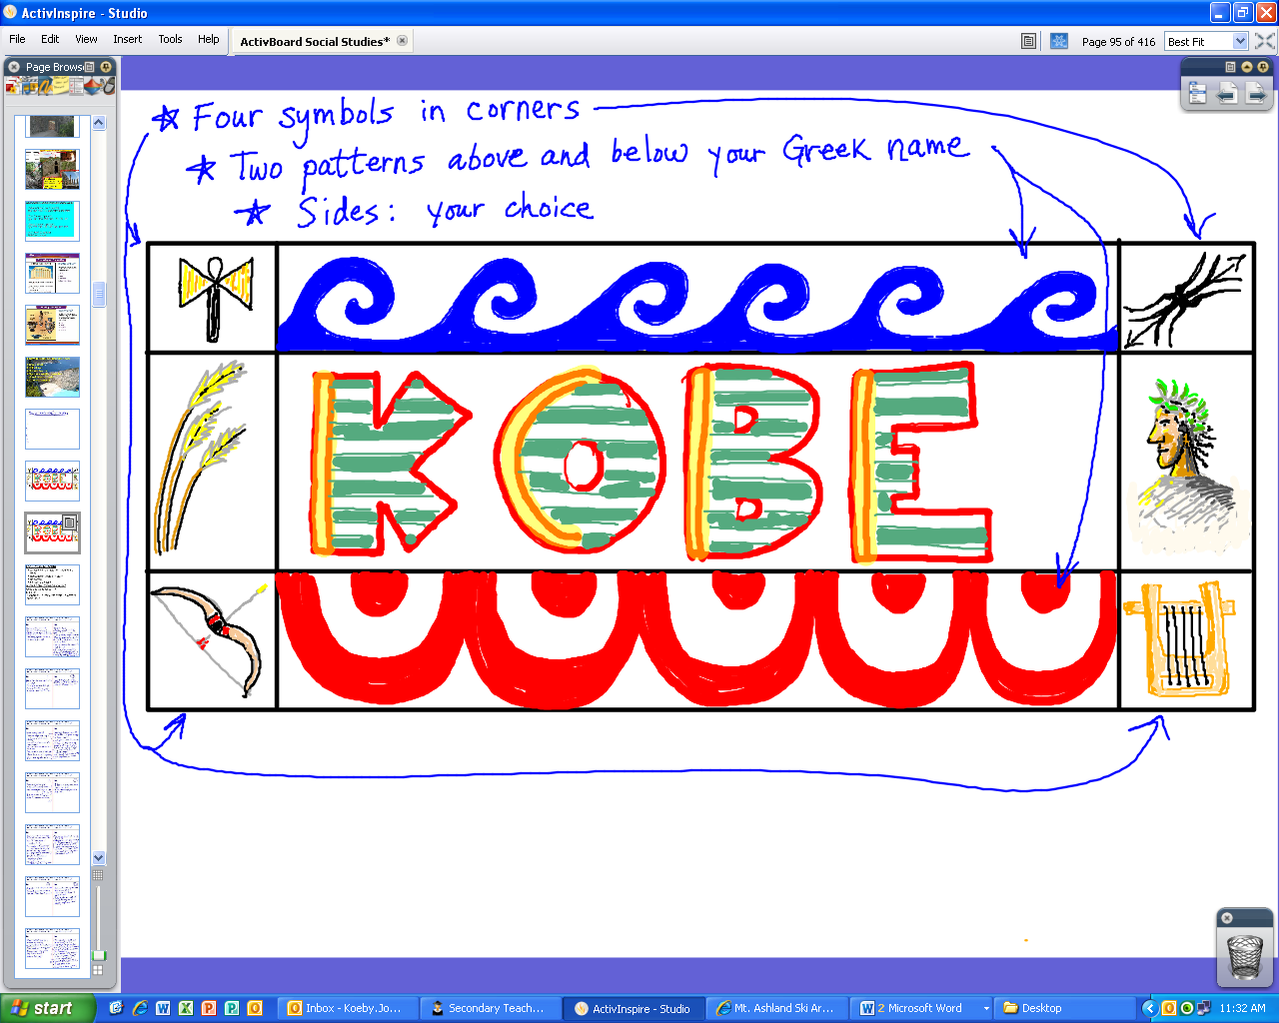

**Symbols and patterns can be found on artifacts at the**

**British Museum website: *www.ancientgreece.co.uk/***[**Cached**](http://webcache.googleusercontent.com/search?q=cache:LeT0KSlIjEkJ:www.ancientgreece.co.uk/+british+museum+ancient+greece&cd=1&hl=en&ct=clnk&gl=us)**-**[**Similar**](http://www.google.com/search?hl=en&safe=active&rls=com.microsoft:en-us&q=related:www.ancientgreece.co.uk/+british+museum+ancient+greece&tbo=1&sa=X&ei=oSa4ToCXN8_ZiQKomZR7&ved=0CB4QHzAA)

**Gods and Goddesses 🡪 Explore**

**They can also be found at johnsonsocialstudies.weebly.com**

**Projects 🡪 Ancient Greek Pottery Collection**

