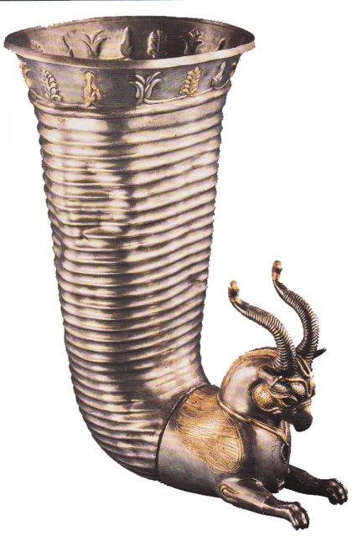

Ancient Persia (Iran) Notes

Use Wikipedia and type "Achaemenid Empire".

1.

The Persian Empire was founded by ________________the

Great. Its eastern boundary was the _____________ Valley,

and its western boundary was the Northeastern border of ____________. It was the ______________ empire the world had ever seen -- spanning ___________ continents. Persia was large and powerful; it had freed the Jewish people from Babylonian slavery, had a _____________ system, _______________ systems, and an official ___________________, but it still fell to the invading army of ______________________________________ around ______________ BCE.

Culture

Herodotus, the Greek historian, reported that Persian youth between the age of 5 and 20, were instructed to ____________________________, to _____________________________, and to

____________________________.

Religion

The main religion of this empire was _____________________________.

What is the most interesting thing you learn about it?

____________________________________________________________________________________________________________________________________________________________________________________________________________________________________________________________________________________________________

What else did you learn about ancient Persia from this article or one of the External Links at the end of the article?

__________________________________________________________________________________________________________________________________________________

__________________________________________________________________________________________________________________________________________________

For MASTERY:

2. Create and name a polygon of the Acheaemenid Empire using Google Earth. Open the *Google Earth* *Ancient Greek Sites* from the Assignments tab of my web site . Create and name a different-colored polygon that covers all the Greek sites. Save both polygons to your W: drive or USB drive.

3. Explore a few of the Greek sites and describe what you find…

Ancient Persia (Iran) Notes

Use Wikipedia and type "Achaemenid Empire".

1.

The Persian Empire was founded by ________________the

Great. Its eastern boundary was the _____________ Valley,

and its western boundary was the Northeastern border of ____________. It was the ______________ empire the world had ever seen -- spanning ___________ continents. Persia was large and powerful; it had freed the Jewish people from Babylonian slavery, had a _____________ system, _______________ systems, and an official ___________________, but it still fell to the invading army of ______________________________________ around ______________ BCE.

Culture

Herodotus, the Greek historian, reported that Persian youth between the age of 5 and 20, were instructed to ____________________________, to _____________________________, and to

____________________________.

Religion

The main religion of this empire was _____________________________.

What is the most interesting thing you learn about it?

____________________________________________________________________________________________________________________________________________________________________________________________________________________________________________________________________________________________________

What else did you learn about ancient Persia from this article or one of the External Links at the end of the article?

__________________________________________________________________________________________________________________________________________________

__________________________________________________________________________________________________________________________________________________

For MASTERY:

2. Create and name a polygon of the Acheaemenid Empire using Google Earth. Open the *Google Earth* *Ancient Greek Sites* from the Assignments tab of my web site . Create and name a different-colored polygon that covers all the Greek sites. Save both polygons to your W: drive or USB drive.

3. Explore a few of the Greek sites and describe what you find…