Film Notes

Name________________________________________

Date_____________________Period_____________

“Pompeii – The Last Day” (http://www.youtube.com/watch?v=sQzDcZE2hoE)

1. What is the name of the volcano that erupted?

2. When did it erupt?

3. What two Roman cities were destroyed by the eruption?

4. Who was Pliny the Younger and what did he do?



5. How was daily life in Pompeii different from yours? Give interesting details:



6. What was found in the boathouses of Herculaneum (Ercolano)?

7. In what year was Pompeii rediscovered by workers building an aqueduct?

8. Describe or draw the “casts” of Pompeii.

9. How many people live “in Vesuvius’ shadow” today?

10. How often do Plinian eruptions occur?

Name

Date Period

Primary Source Analysis:

* Use Google Earth to fly to Pompeii, Italy
* Browse photos of the ancient city
* Find a photo that shows ***primary source*** information about life in this ancient Roman city
* Copy and paste the photo into a Word document
* Write a detailed description of what you see in the photo and what you think it shows about life in the city

*An example…*

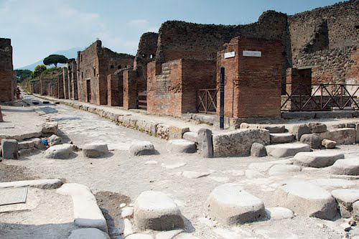

The photograph of Pompeii that I found on Google Earth shows the intersection of four paved streets. The surface of the roads is made of crushed stone and larger grey paving stones. The sidewalk is raised and has a stone curb like our streets today, probably to keep muddy rain water from getting up where pedestrians walked. There are large raised stone crosswalks, probably for the same reason. There are gaps in between the crosswalk stones, so horse-drawn carts would be able to pass through! It is clear that the builders of this city must have been very good planners. The buildings are organized, rectangular, red brick structures, but they are partly in ruins. The tops of the buildings are blackened – maybe from the volcanic ash? In the distance behind the buildings, the volcano – Mt. Vesuvius – can faintly be seen!