Renaissance Italy
Name____________________________
Date_____________ Period__________

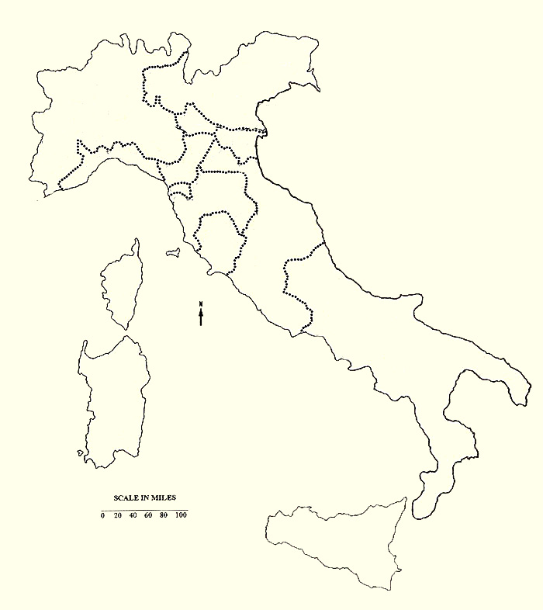
Map of Renaissance Italy

On the map on the back of this sheet, color the following city states. Use the map on page 609 of Journey Across Time. You may also need to use the textbook atlas to find some of the bodies of water.

City States
Finally, label the following bodies of water on your map.
- Adriatic Sea
- Mediterranean Sea
- Tyrrhenian Sea
- Ionian Sea
- Ferrara
- Florence
- Genoa
- Lucca
- Mantua
- Milan
- Modena
- Papal States
- Siena
- Two Sicilies
- Venice
Next, label the following cities.

Cities
- Florence
- Genoa
- Mantua
- Milan
- Naples
- Pisa
- Siena

