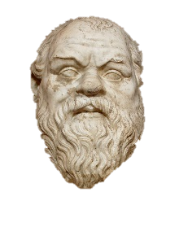
“When the debate is lost, slander becomes the tool of the loser.”
~ Socrates, 400 BC

Name _________________________________________

Date __________________________ Period __________
Self-check for Argumentative Writing
Use this sheet to help you in the writing process of your argumentative writing.

Topic: _______________________________________________________________________

Revision
- Do you have a precise thesis statement stating your claim in the introduction paragraph? yes or no
Write it out here completely: ________________________________________________________________________________________________________________________________________________________________________________________________________________________
- What are two pieces of supporting evidence you use to back-up your claim?
________________________________________________________________________________________________________________________________________________________________________________________________________________________________________________________________________________________________

- What is the alternate/opposing claim (what is the evidence against your position?) ________________________________________________________________________________________________________________________________________________
- Does your paper have at least three paragraphs (introduction, body, conclusion)? yes or no
- Do you have at least five GIST words (key terms and phrases) in your essay?
List your GIST words here:______________________________________________________
______________________________________________________________________________
- Is there an appropriate distance between reader and writer? This means a formal, third person voice – no “I think” or “you” statements. yes or no
- Do you have a concise final statement based on your thesis and the evidence you presented? yes or no Write it out here: ________________________________________________________________________________________________________________________________________________________________________________________________________________________

Final Editing:
- Read your paper OUT LOUD. Make sure your spelling, capitalization, and punctuation are correct. If typed, use Times New Roman or Arial, 12 point font, double-spaced.

