Countries I have visited =

Countries I want to visit = Name______________________________________ Date ________ Period ___

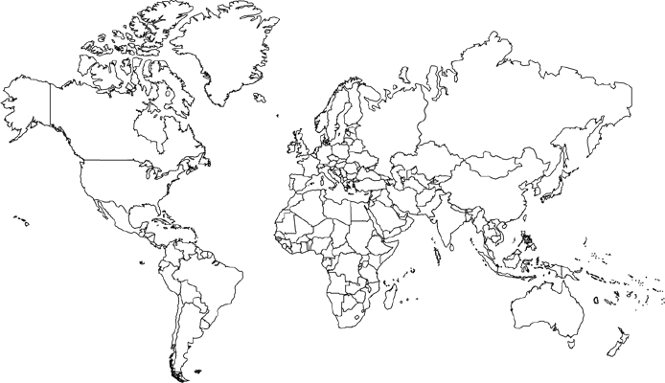

States I have visited =

States I want to visit = Name______________________________________ Date ________ Period ___

