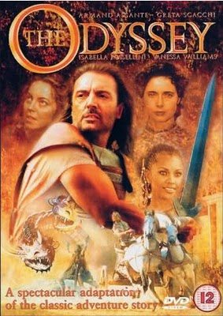

On November 21st, Team 7-3 is going to travel along with Odysseus as he sails through Homer’s classic, The Odyssey!

Actually, because tickets on Delta Airlines from Medford to Athens are

a bit steep right now – the cheapest flight I found was $768.00

per person – *we will instead be watching the feature film*!

Because the film is rated PG-13, your child needs to return this

signed permission slip, or he/she will not be able to watch the

movie with us – although I will make an alternate assignment

available to them.

*I give my child, _______________________________________,*

*permission to watch the film The Odyssey.*

Parent Signature_______________________________________

Any questions?

Email me: [koeby.johnson@medford.k12.or.us](mailto:koeby.johnson@medford.k12.or.us)

On November 21st, Team 7-3 is going to travel along with Odysseus as he sails through Homer’s classic, The Odyssey!

Actually, because tickets on Delta Airlines from Medford to Athens are

a bit steep right now – the cheapest flight I found was $768.00

per person – *we will instead be watching the feature film*!

Because the film is rated PG-13, your child needs to return this

signed permission slip, or he/she will not be able to watch the

movie with us – although I will make an alternate assignment

available to them.

*I give my child, _______________________________________,*

*permission to watch the film The Odyssey.*

Parent Signature_______________________________________

Any questions?

Email me: [koeby.johnson@medford.k12.or.us](mailto:koeby.johnson@medford.k12.or.us)