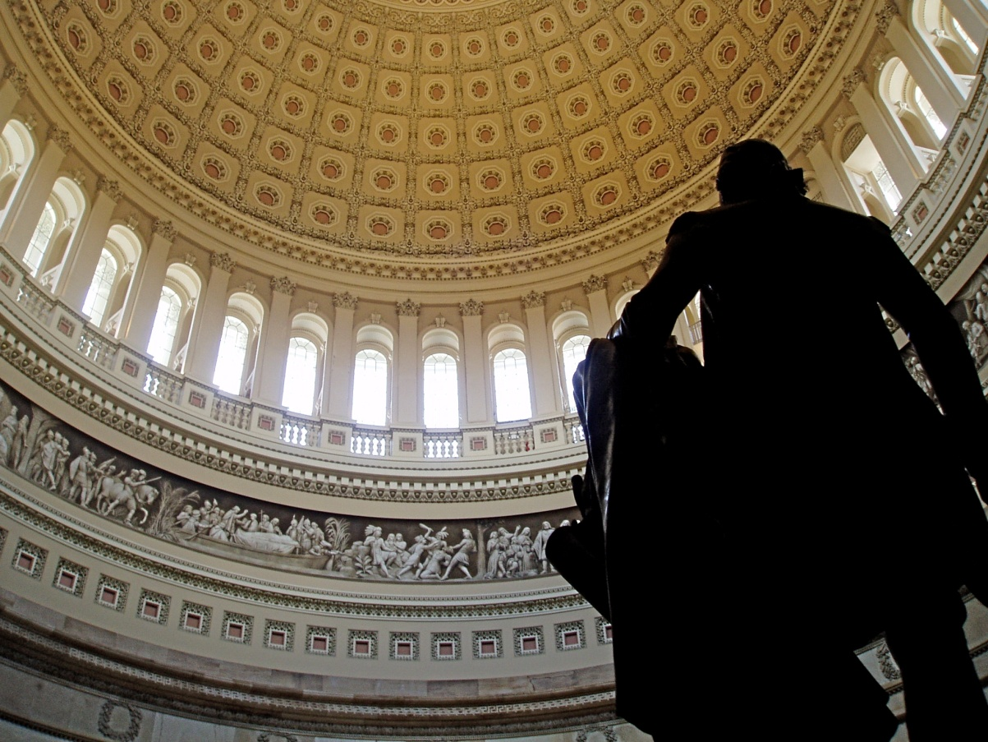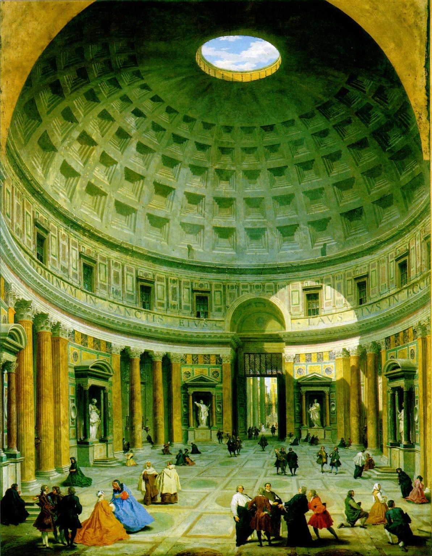

The United States Capitol Building

Washington, D.C., United States

The Pantheon,

Rome, Italy