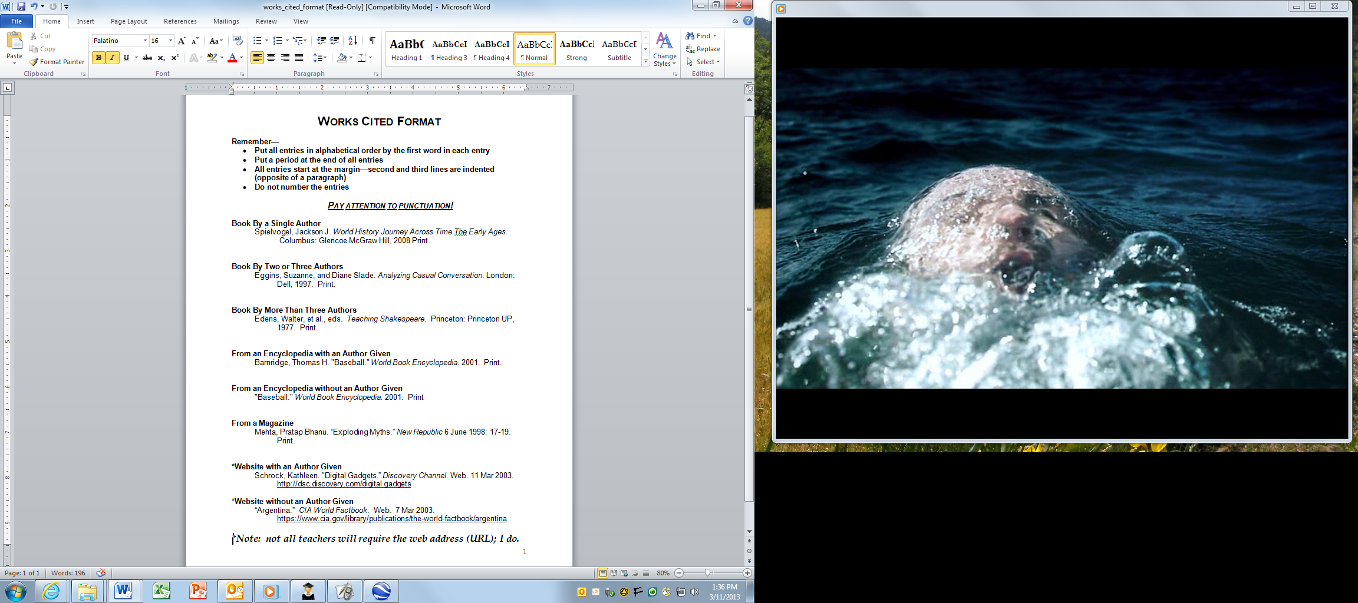

Use this Works Cited Format 🡪

to cite two or more sources of information you used to create your World Religions Venn Diagram.